Proposed Title: -

**VIRTUAL VOTING MACHINE**

Submitted as a part of the course curriculum for

**Bachelor of Technology**

**in**

**Computer Science**



**MENTOR**: Ms. Akanksha

**MEMBERS**:

Surya Pratap Singh (2000290120169)

Utkarsh Mishra (2000290120180)

Adrika Tripathi

**Field of Invention**: -

**Blockchain Technology**: The core technology behind virtual voting machines is blockchain. This field involves the development of distributed ledger systems, consensus algorithms, smart contracts, and cryptographic techniques to create secure and transparent voting systems.

**Cryptography**: Cryptography plays a critical role in securing the integrity and privacy of votes in blockchain-based voting systems. Researchers in this field work on encryption, digital signatures, and privacy-preserving protocols.

**Computer Science**: Innovations in computer science, such as software development, network security, and database management, are essential for building the software and infrastructure of virtual voting machines.

**Information Security**: Ensuring the security of virtual voting machines is of utmost importance. Information security experts work on identifying vulnerabilities, mitigating threats, and implementing robust security measures.

**Background**: -

The development of virtual voting machines using blockchain technology represents an innovative approach to modernizing the electoral process. Here is some background information on the concept:

1. **Traditional Voting Challenges**: Traditional voting systems often face challenges such as fraud, tampering, long queues at polling stations, and difficulties for absentee voters. Counting and verifying votes can also be time-consuming and error-prone.

2. **Emergence of Blockchain Technology**: Blockchain technology, originally created for cryptocurrencies like Bitcoin, has gained attention for its potential to address some of the shortcomings in various industries. It is essentially a distributed ledger that records transactions across a network of computers in a secure, transparent, and immutable manner.

3. Key Features of Blockchain for Voting:

**Security**: Blockchain's decentralized nature and cryptographic features make it highly resistant to tampering and fraud. Once a vote is recorded on the blockchain, altering it becomes extremely difficult.

**Transparency**: All transactions (in this case, votes) on the blockchain are publicly recorded, providing a transparent and auditable trail of every vote cast.

**Accessibility**: Virtual voting systems can potentially make voting more accessible to a wider range of people, including those with disabilities and those unable to physically visit a polling station.

**Objective**: -

The objectives of implementing virtual voting machines using blockchain technology are to address and improve various aspects of the traditional voting process. These objectives aim to enhance the integrity, transparency, accessibility, and efficiency of elections. Here are the key objectives of virtual voting machines using blockchain:

**Enhanced Security**:

To provide a highly secure voting system that is resistant to hacking, fraud, and tampering.

To ensure that votes are securely recorded and cannot be altered once cast.

Transparency and Auditability:

To create a transparent and immutable ledger of all votes cast, accessible for public scrutiny.

To enable real-time tracking and auditing of the voting process, ensuring the accuracy of results.

Accessibility:

To make voting more accessible to a wider range of citizens, including those with disabilities and remote or absentee voters.

To eliminate geographical constraints, enabling voters to cast their ballots from anywhere with an internet connection.

**Privacy Protection**:

To maintain the privacy of voters by using cryptographic techniques to ensure that individual votes cannot be linked to specific voters.

To strike a balance between transparency and privacy, allowing voters to verify their own votes while keeping their choices confidential.

**Flow chart: -**

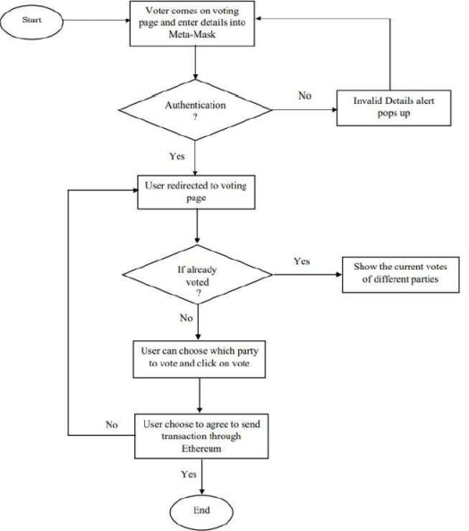

**Claims (Novel/Innovative ideas): -**

**Claim**: Blockchain technology provides a highly secure and tamper-resistant platform for voting.

**Explanation:** Votes recorded on the blockchain are immutable and protected by cryptographic algorithms, reducing the risk of hacking or manipulation.

**Claim:** The use of blockchain ensures transparency by creating a publicly accessible and tamper-evident ledger of all votes.

**Explanation:** Anyone can verify the authenticity of votes and the integrity of the electoral process by examining the blockchain.

**Claim:** Virtual voting machines make voting more accessible to a broader range of voters, including those with disabilities and remote or overseas voters.

**Explanation:** Online voting can eliminate physical barriers, allowing voters to cast their ballots from anywhere with an internet connection.

**Claim:** Blockchain-based voting systems can streamline the voting process and reduce the time needed to count and announce results.

**Explanation**: Automation and smart contracts can expedite the vote-counting process and minimize errors.

**Claim:** Implementing virtual voting machines can lead to cost savings in terms of printing ballots, setting up polling stations, and manual vote counting.

**Explanation:** Reduced reliance on physical resources and manpower can lead to cost efficiencies.

**Claim**: Virtual voting machines enable citizens living abroad or in remote areas to participate in elections conveniently.

**Explanation:** Remote voting options can cater to individuals who cannot physically visit polling stations.

**Technology Used: -**

* Blockchain
* Solidity: Smart Contracts
* React.js: Frontend
* Node.js: Backend
* MetaMask: Crypto Wallet

**Abstract: -**

In this project, we are building an online voting mechanism which will allow people to cast their vote online from anywhere. Vote casting will be decentralized and transparent. One person will be allowed to give only one vote after verifying their identity. For developing E-voting machine using blockchain we used Ethereum – a popular platform for creating distributed blockchain application that support smart contract.

**Advantages: -**

• People will be able to vote anywhere, anytime.

• Faster and decentralized.

• Casting of votes will be fully transparent.

• Votes are immutable.

• Anonymity

• Singularity and Vote Privacy

**Conclusion: -**

Virtual voting machines using blockchain technology have the potential to revolutionize the electoral process by providing increased transparency, security, and accessibility. However, several key considerations and challenges should be considered when drawing conclusions about their feasibility and effectiveness:

Enhanced Security: Blockchain's decentralized and immutable ledger can significantly enhance the security of the voting process. It can help protect against tampering, fraud, and hacking, which have been concerns in traditional voting systems.

Transparency: The transparency provided by blockchain ensures that every vote cast is recorded and can be audited by relevant parties. This transparency can help build trust in the electoral process.

Accessibility: Virtual voting machines can potentially make it easier for people to vote, especially those who may have difficulties with physical voting locations. However, ensuring that these systems are accessible to all, including those with disabilities and those without internet access, is a critical consideration.

Identity Verification: Establishing a secure and reliable method for verifying voters' identities in a virtual environment is essential to prevent voter fraud.

In conclusion, virtual voting machines using blockchain have the potential to address many of the challenges and concerns associated with traditional voting systems. However, successful implementation requires careful planning, robust security measures, regulatory support, and public trust. Further research, development, and real-world testing are necessary to determine their suitability for widespread adoption in elections.